RECIPROCAL NON-DISCLOSURE AGREEMENT

BETWEEN:

THE UNIVERSITY OF BRITISH COLUMBIA, a corporation continued under the University Act of British Columbia with offices at 103-6190 Agronomy Road, Vancouver, British Columbia, V6T 1Z3, Attention: Managing Director, University-Industry Liaison Office, Telephone: (604) 822-8580

(“UBC”)

AND:
Click here to enter text., a corporation having an office at Click here to enter text. Attention:Click here to enter text., Telephone: Click here to enter text.

(the “Partner”)

WHEREAS:

UBC and the Partner will be collaborating on a UBC engineering student led project in order to explore solutions to Partner problems through applied research. Both UBC and the Partner anticipate that one party (the “Provider”) may wish to disclose, deliver or transmit to the other party (the “Recipient”) certain confidential or proprietary information and materials.

THE PARTIES AGREE AS FOLLOWS:

- CONFIDENTIAL INFORMATION.

  - Provider will provide Recipient with information concerning Click here to enter text. which are clearly marked as confidential or proprietary when first disclosed (“Confidential Information”) and include, without limitation, trade secrets, know-how, show-how, concepts, discoveries, inventions, research or technical data and other proprietary information. Confidential Information may also include information furnished during discussions or oral presentations if it is conspicuously identified as proprietary at the time and then transcribed or confirmed in writing within 30 days, specifically describing what portions of such information is considered to be proprietary or confidential. However, Recipient is under no obligation to maintain the confidentiality of Confidential Information which Recipient can show:
- is or subsequently becomes generally available to the public through no act or fault of Recipient;
- was in the possession of Recipient prior to its disclosure by the Provider to the Recipient;
- was lawfully acquired by Recipient from a third party who was not under an obligation of confidentiality to Provider;
- was independently developed by employees, agents or consultants of the Recipient who had no knowledge of or access to the Provider’s Confidential Information as evidenced by the Recipient’s records; or
- is required by an order of a legal process to disclose, provided that Recipient gives Provider prompt and reasonable notification of such requirement prior to disclosure.

- OWNERSHIP.

  - The Confidential Information is and will at all times remain the exclusive property of Provider and nothing in this Agreement grants the Recipient any right, title or interest in or to the Confidential Information.

- DISCLAIMER OF WARRANTY.

  - Recipient acknowledges and agrees that the Confidential Information is experimental in nature and that any use of the Confidential Information by Recipient will be at the sole risk and liability of Recipient. PROVIDER MAKES NO REPRESENTATION OR WARRANTY, WHETHER EXPRESSED OR IMPLIED, WITH RESPECT TO THE CONFIDENTIAL INFORMATION, INCLUDING ANY REPRESENTATION OR WARRANTY AS TO ITS ACCURACY, COMPLETENESS, MERCHANTABILITY OR FITNESS FOR A PARTICULAR PURPOSE OR NON-INFRINGEMENT ON THIRD PARTY PROPRIETARY RIGHTS. ALSO, PROVIDER WILL NOT BE LIABLE FOR ANY INDIRECT, SPECIAL, INCIDENTAL OR CONSEQUENTIAL DAMAGE OR LOSS ARISING FROM ANY USE OF THE CONFIDENTIAL INFORMATION BY RECIPIENT EVEN IF PROVIDER HAS BEEN ADVISED OF THE POSSIBILITY OF SUCH DAMAGE OR LOSS.

- USE & PERIOD OF CONFIDENTIALITY.

  - Recipient will not use the Confidential Information for any purpose other than to evaluate the Confidential Information to determine Click here to enter text.. Recipient will not disclose any Confidential Information to third parties or to employees of Recipient, except to those employees who are required to have the Confidential Information in order to evaluate or engage in discussions concerning the contemplated relationship. Recipient will not de-compile or reverse engineer the Confidential Information or use the Confidential Information to develop, or cause to develop, all or part of any process or product whether for internal use or for commercial purposes.

  - Recipient will use the Confidential Information for the purpose set out in Article 4.1 for a period commencing on the date of this Agreement and ending 8 months thereafter unless terminated earlier by one party upon giving the other party at least 5 business days written notice. At the end of such period and at the written request of Provider, Recipient will return or destroy all copies of the Confidential Information, except that Recipient may provide a sealed copy of the Confidential Information to its legal counsel for archival purpose.

  - Recipient will use the same care and discretion to avoid disclosure of the Confidential Information as Recipient uses with its own similar information that the Recipient does not wish to disclose for a period of 5 years from the date of this Agreement irrespective of the expiration or earlier termination of the period of use described in Article 4.2.

- ASSIGNMENT.

  - Neither party may assign all or part of this Agreement without the prior written consent of the other party, whose consent will not be unreasonably withheld.

- GENERAL.

  - No provision of this Agreement will be deemed waived or any breach excused, unless such waiver or consent excusing the breach is in writing and signed by the Provider. A waiver of a provision of this Agreement will not be construed to be a waiver of a subsequent breach of the same provision.

  - This Agreement contains the entire agreement and understanding of the parties with respect to its subject matter and supersedes all prior proposals, negotiations, agreements, understandings, representations and warranties of any form or nature, whether oral or written, and whether express or implied, which may have been entered into between the parties relating to its subject matter. This Agreement may be signed in counterparts either through original copies or by facsimile or electronically each of which will be deemed an original and all of which will constitute the same instrument.

  - In this Agreement, unless the contrary intention appears, “days” means calendar days.

SIGNED BY THE PARTIES AS AN AGREEMENT and effective as of the date of the last signature.

THE UNIVERSITY OF BRITISH COLUMBIA Click here to enter text.

by its duly authorized officer: by its duly authorized officer:
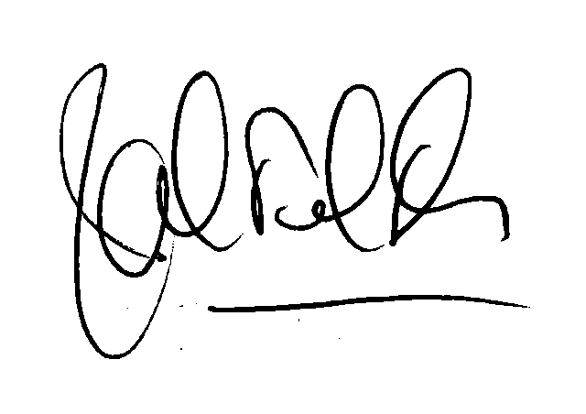
___________________________________ _____________________________
Name: Dr. J.P. Heale Name: Click here to enter text.
Title: Managing Director, UILO Title: Click here to enter text.

Date: Click here to enter a date. Date: Click here to enter a date.

We, the undersigned students, faculty, and staff working on this individual capstone project have read and understood this Confidentiality Agreement and the obligations it entails:

Name: Click here to enter text.
Position: Click here to enter text.
Date: Click here to enter a date.

Name: Click here to enter text.
Position: Click here to enter text.
Date: Click here to enter a date.

Name: Click here to enter text.
Position: Click here to enter text.
Date: Click here to enter a date.

Name: Click here to enter text.
Position: Click here to enter text.
Date: Click here to enter a date.

Name: Click here to enter text.
Position: Click here to enter text.
Date: Click here to enter a date.

Name: Click here to enter text.
Position: Click here to enter text.
Date: Click here to enter a date.

Name: Click here to enter text.
Position: Click here to enter text.
Date: Click here to enter a date.

Name: Click here to enter text.
Position: Click here to enter text.
Date: Click here to enter a date.

Name: Click here to enter text.
Position: Click here to enter text.
Date: Click here to enter a date.

Name: Click here to enter text.
Position: Click here to enter text.
Date: Click here to enter a date.

Name: Click here to enter text.
Position: Click here to enter text.
Date: Click here to enter a date.

Name: Click here to enter text.
Position: Click here to enter text.
Date: Click here to enter a date.

